Lesson 16

Target: I can add and subtract two fractions with the same units using visual models.

Concept Development (33 minutes)

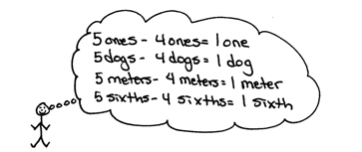Materials: (S) Personal white board, blank number lines (Template)

Problem 1: Solve for the difference using unit language and a number line.

T: (Project 5 – 4.) Solve. Say the number sentence using units of ones.

S: 5 ones – 4 ones = 1 one.

T: Say the number sentence if the unit is dogs.

S: 5 dogs – 4 dogs = 1 dog.

|  |  |
| --- | --- |
|  | NOTES ON  MULTIPLE MEANS  OF REPRESENTATION: |
| Be sure to articulate the ending digraph */th/* to distinguish *six* from *sixth* for English language learners.Coupling spoken expressions with words or models may also improve student comprehension. For example, write out *5 sixths – 4 sixths = 1 sixth.* | |

T: Say the number sentence if the unit is meters.

S: 5 meters – 4 meters = 1 meter.

T: Say the number sentence if the unit is sixths.

S: 5 sixths – 4 sixths = 1 sixth.

T: Let’s show that 5 sixths – 4 sixths = 1 sixth.

T: (Project a number line with endpoints 0 and 1, partitioned into sixths.) Make tick marks on the first number line on your Template to make a number line with endpoints 0 and 1 above the number line. Partition the number line into sixths. (See the illustration on the next page.)

T: Draw a point at 5 sixths. Put the tip of your pencil on the point. Count backward to subtract 4 sixths.

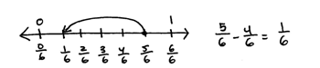

T: Move your pencil and count back with me as we subtract.

S: 4 sixths, 3 sixths, 2 sixths, 1 sixth!

T: Draw one arrow above the number line to model $\frac{\text{5}}{\text{6}}$– $\frac{\text{4}}{\text{6}}$. (Demonstrate.) Tell me the subtraction sentence.

S: $\frac{\text{5}}{\text{6}}\text{–}\frac{\text{4}}{\text{6}}\text{=}\frac{\text{1}}{\text{6}}$.

Repeat with $\frac{\text{7}}{\text{8}}$– $\frac{\text{3}}{\text{8}}$.

|  |  |
| --- | --- |
|  | NOTES ON  MULTIPLE MEANS  OF ENGAGEMENT: |
| Students working above grade level and others may present alternative subtraction strategies, such as counting up rather than counting down to solve $\frac{\text{7}}{\text{6}}\text{–}\frac{\text{5}}{\text{6}}$. Though not introduced in this lesson, the appropriate use of these strategies is desirable and is introduced later in the module. | |

T: Solve for 7 sixths – 2 sixths. Work with a partner.   
Use the language of units and subtraction.

S: 7 sixths – 2 sixths = 5 sixths. 🡪 I know 7 ones minus   
2 ones is 5 ones. I can subtract sixths like I subtract ones. $\frac{\text{7}}{\text{6}}\text{–}\frac{\text{2}}{\text{6}}\text{=}\frac{\text{5}}{\text{6}}.$

T: Discuss with your partner how to draw a number line to represent this problem.

S: We partition it like the first problem and draw the arrow to subtract. 🡪 But $\frac{\text{7}}{\text{6}}$ is more than 1 whole.   
6 sixths is equal to 1. We have 7 sixths. 🡪 Let’s make the number line with endpoints 0 and 2.

T: Label the endpoints 0 and 2. Partition the number line into sixths. Subtract.

S: On the number line, we started at 7 sixths and then went back 2 sixths. The answer is 5 sixths.   
🡪 .

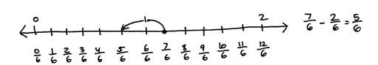

Repeat with $\frac{7}{4}-\frac{5}{4}$.

Problem 2: Decompose to record a difference greater than 1 as a mixed number.

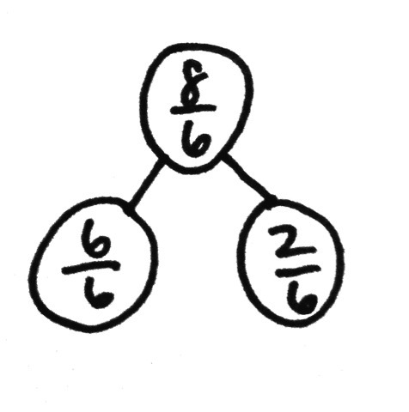T: (Display 10 sixths – 2 sixths.) Solve in unit form, and write a number sentence using fractions.

S: (Write 10 sixths – 2 sixths = 8 sixths and $\frac{\text{10}}{\text{6}}\text{–}\frac{\text{2}}{\text{6}}\text{=}\frac{\text{8}}{\text{6}}$.)

T: Use a number bond to decompose $\frac{\text{8}}{\text{6}}$ into the whole and fractional parts.

S: (Draw a number bond as pictured to the right.)

T: $\frac{\text{6}}{\text{6}}$ is the same as…?

S: 1 whole.

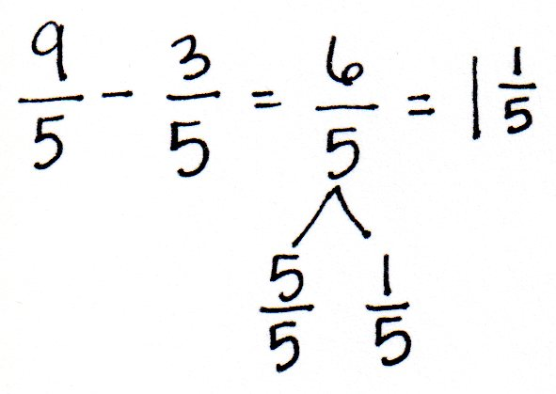T: We can rename $\frac{\text{8}}{\text{6}}$ as a **mixed number**, $\text{1}\frac{\text{2}}{\text{6}}$, using a whole number   
and fractional parts.

Repeat with 9 fifths – 3 fifths.

Problem 3: Solve for the sum using unit language and a number line.

T: Look back at the first example. (Point to the number line representing 5 sixths – 4 sixths.) Put your finger on 1 sixth. To 1 sixth, let’s add the 4 sixths that we took away.

T: Count as we add. 1 sixth, 2 sixths, 3 sixths, 4 sixths. Where are we now?

S: 5 sixths.

T: What is 1 sixth plus 4 sixths?

S: 5 sixths.

T: Let’s show that on the number line. (Model with students as shown to the right.)

T: 1 one plus 4 ones is…?

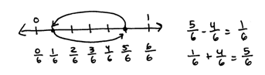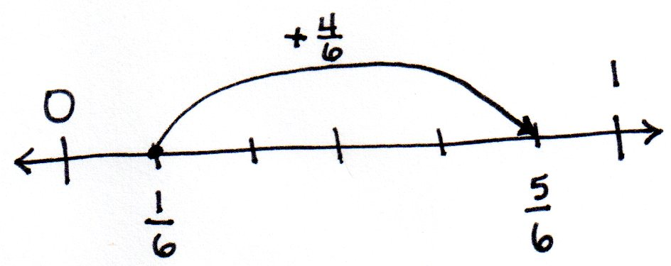

S: 5 ones.

T: 1 apple plus 4 apples is…?

S: 5 apples.

T: 1 sixth plus 4 sixths equals…?

S: 5 sixths.

Repeat with $\frac{\text{2}}{\text{8}}\text{+}\frac{\text{3}}{\text{8}}\text{=}\frac{\text{5}}{\text{8}}.$

Problem 4: Decompose to record a sum greater than 1 as a mixed number.

T: (Display 5 fourths + 2 fourths.) Solve in unit form, and write a number sentence using fractions.

S: (Write 5 fourths + 2 fourths = 7 fourths and $\frac{\text{5}}{\text{4}}\text{+}\frac{\text{2}}{\text{4}}\text{=}\frac{\text{7}}{\text{4}}$.)

T: Use a number bond to decompose $\frac{\text{7}}{\text{4}}$ into the whole and some parts.

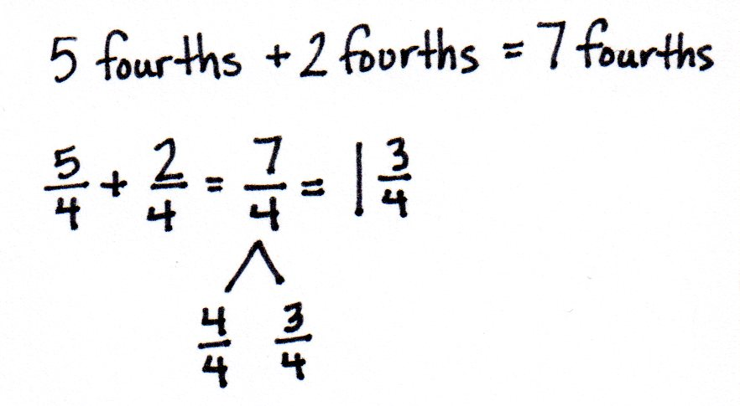S: (Draw a number bond as pictured to the right.)

T: $\frac{\text{4}}{\text{4}}$ is the same as…?

S: 1 whole.

T: We can rename $\frac{\text{7}}{\text{4}}$ as a mixed number, $\text{1}\frac{\text{3}}{\text{4}}$.

Name Date

1. Solve.

|  |  |
| --- | --- |
| 1. 3 fifths + 1 fifth = _______________ | 1. 5 tenths + 3 tenths = _______________ |
| 1. 3 halves – 2 halves = _______________ | 1. 6 fourths – 3 fourths = _______________ |

1. Solve.
$\frac{5}{6} - \frac{3}{6}$

$\frac{6}{8} - \frac{4}{8}$

$\frac{3}{10}+ \frac{3}{10}$

$\frac{5}{5}+ \frac{4}{5}$

2. Solve. Use a number bond to show how to convert the difference to a mixed number. Problem (a) has been completed for you.



$\frac{\text{9}}{\text{8}} =1\frac{1}{8}$

$$\frac{8}{8} \frac{1}{8}$$

$\frac{12}{8} - \frac{3}{8}=$

$\frac{1}{6}+ \frac{4}{6}$

$\frac{4}{5}+ \frac{3}{5}$

$\frac{4}{8}-\frac{3}{8}$

Name Date [1]

1. blank number lines